The download uses the fields PERSON.ACTV.CUI.RL.LONG.CUI and PERSON.INAC.CUI.RL.LG.CUI.
PERSON.ACTV.CUI.RL.LONG.CUI:
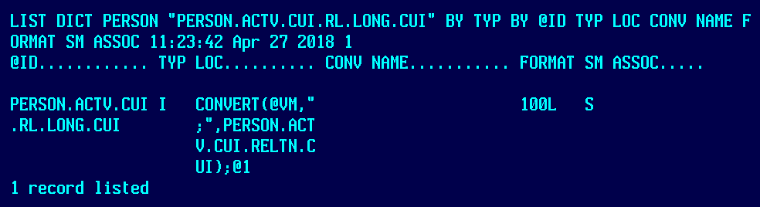
Which is built from:
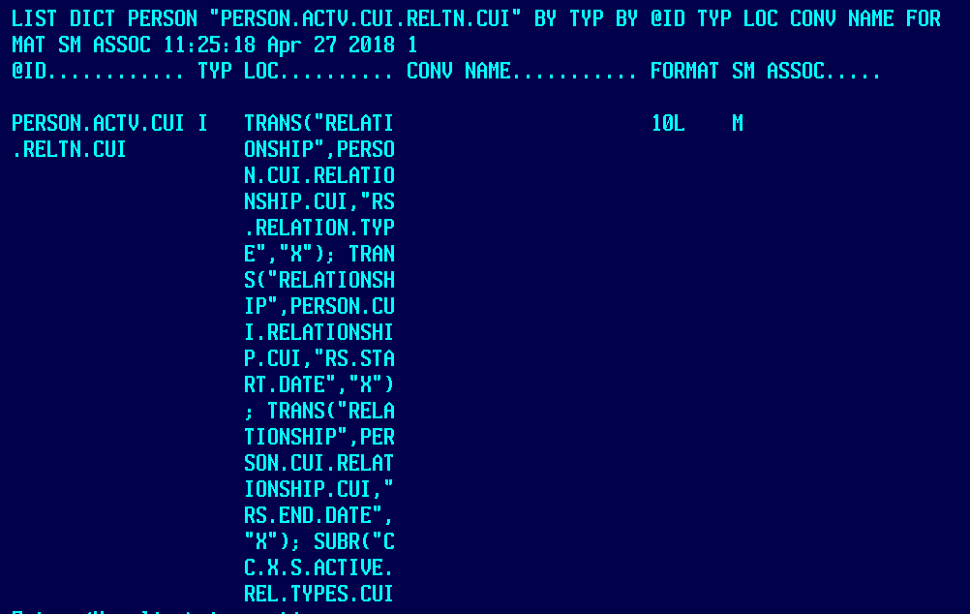
With subroutine CC.X.S.ACTIVE.REL.TYPES.CUI:
**********************************************************************
* Created by: Datatel, Central College
* Date: July 27, 2009
*---------------------------------------------------------------------
* Description:
*
* Subroutine to return a list of active relation types from a list
* Output - List of active relation types
* Input - List of relation types
* Input - List of start dates
* Input - List of end dates
*
**********************************************************************
*
* Initialize stuff.
*
XL.ACTIVE.REL.TYPES = ""
XL.REL.TYPES = AL.REL.TYPES
XL.START.DATES = AL.START.DATES
XL.END.DATES = AL.END.DATES
X.COUNT = DCOUNT(XL.REL.TYPES,@VM)
X.FND = 0
X.TODAY = DATE()

FOR X = 1 TO X.COUNT
X.S.DATE = XL.START.DATES<1,X>
X.E.DATE = XL.END.DATES<1,X>
IF ((X.S.DATE = "") OR (X.S.DATE <= X.TODAY)) THEN
IF ((X.E.DATE = "") OR (X.E.DATE >= X.TODAY)) THEN
IF X.FND > 0 THEN
XL.ACTIVE.REL.TYPES := @VM : XL.REL.TYPES<1,X>
END ELSE
XL.ACTIVE.REL.TYPES := XL.REL.TYPES<1,X>
X.FND = 1
END
END
END
NEXT X
*
AL.ACTIVE.REL.TYPES = XL.ACTIVE.REL.TYPES
*

PERSON.INAC.CUI.RL.LG.CUI:
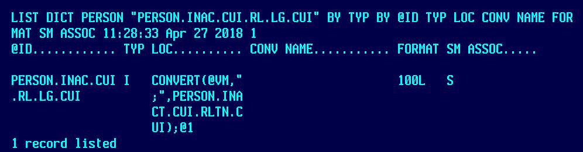
Which is built from:
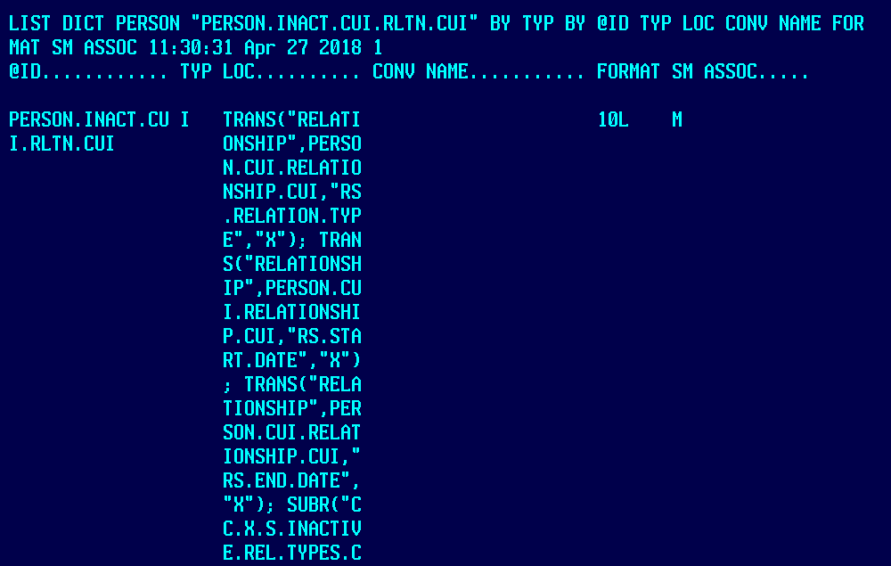
With subroutine CC.X.S.INACTIVE.REL.TYPES.CUI:
**********************************************************************
* Created by: Datatel, Central College
* Date: July 27, 2009
*---------------------------------------------------------------------
* Description:
*
* Subroutine to return a list of inactive relation types from a list
* Output - List of inactive relation types
* Input - List of relation types
* Input - List of start dates
* Input - List of end dates
*
**********************************************************************
*
* Initialize stuff.
*
XL.INACTV.REL.TYPES = ""
XL.REL.TYPES = AL.REL.TYPES
XL.START.DATES = AL.START.DATES
XL.END.DATES = AL.END.DATES
X.COUNT = DCOUNT(XL.REL.TYPES,@VM)
X.FND = 0
X.TODAY = DATE()

FOR X = 1 TO X.COUNT
X.S.DATE = XL.START.DATES<1,X>
X.E.DATE = XL.END.DATES<1,X>
IF (((X.E.DATE # "") AND (X.E.DATE <= X.TODAY)) OR (X.S.DATE > X.TODAY)) THEN
IF X.FND > 0 THEN
XL.INACTV.REL.TYPES := @VM : XL.REL.TYPES<1,X>
END ELSE
XL.INACTV.REL.TYPES := XL.REL.TYPES<1,X>
X.FND = 1
END
END
NEXT X
*
AL.INACTV.REL.TYPES = XL.INACTV.REL.TYPES
*

Sample List Statement and Results:
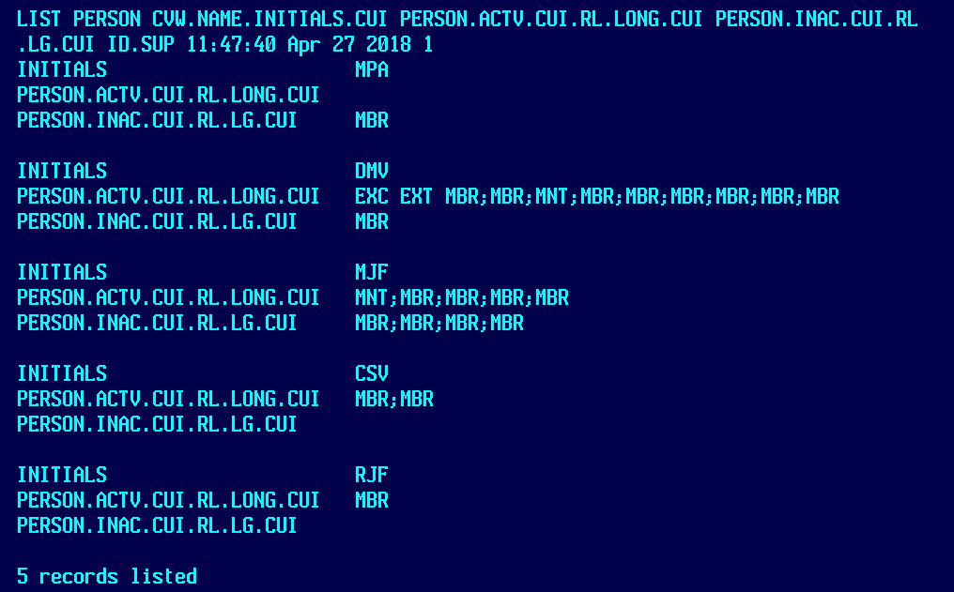

Sample DOWNLOAD Statement and Results:
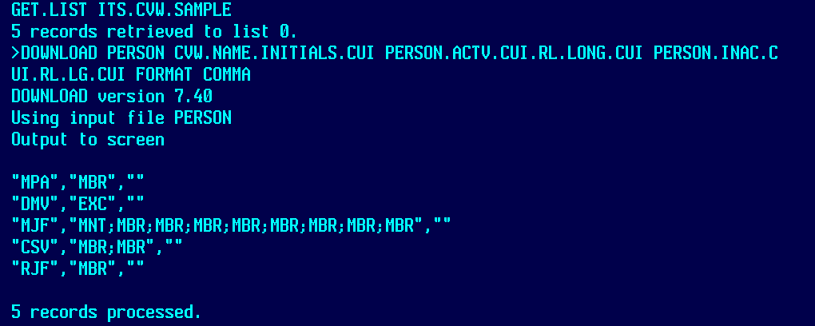

The LIST statement uses the same savedlist as was used for the DOWNLOAD. Also, we are aware of the differences on the record with DMV in CVW.NAME.INITIALS.CUI, as there are subvalue marks that need to be converted as the value marks were.

